**RETAIL STORE MANAGEMENT SYSTEM**

Project submitted to the

SRM University – AP, Andhra Pradesh

for the partial fulfillment of the requirements to award the degree of

**Bachelor of Technologyg**

In

**Computer Science and Engineering**

**School of Engineering and Sciences**

Submitted by

**Ankitha Devi Gangavarapu**

**AP20110010389**

Under the Guidance of

**Dr.Rajiv Senapati**

**SRM University–AP**

**Neerukonda, Mangalagiri, Guntur**

**Andhra Pradesh – 522 240**

**[December, 202**

# Certificate

Date: 16-Nov-22

This is to certify that the work present in this Project entitled Retail Store Management System has been carried out by **G.Ankitha devi** under my supervision. The work is genuine, original, and suitable for submission to the SRM University – AP for the award of Bachelor of Technology/Master of Technology in **School of Engineering and Sciences**.

**Supervisor**

(Signature)

Prof. [Rajiv Senapati](mailto:rajiv.s@srmap.edu.in)

Designation,

Affiliation.

# 

**Acknowledgements**

We thank **Dr.Rajiv Senapati sir**, our professor in charge, for the help and direction in finishing our project on the subject Database Management System. It was a fantastic learning opportunity.This subject has given me an opportunity to explore the field I have always been curious about. Your insightful counsel and recommendations were quite beneficial to me as I finished the assignment. I will always be grateful to you for this.

# 

# 

# 

# 

# 

# 

# 

# 

# 

# 

# 

# 

# 

# 

# 

# 

# 

# 

# 

# 

# Table of Contents

Certificate i

Acknowledgements iii

v

Abstract v

1. Introduction 1

2. Entity Relationship Model

2.1 Entity list 3

2.1.1 Attribute list of each entity 3

3. Relational Schema 5

4. Normalization 5

5. SQL Queries 8

References 11

# Abstract

Grocery, clothing and drug stores etc. are considered to be retail stores. Retail Store Management system helps the user to manage the store in a better way. It contains complete information(store details, employee details, cutomer information, product records) about the store.

This project only contains organization of the data of a particular store(backend).

# Introduction

There are many different ways to store and retrieve the data. Older versions like using files for data organizing have many issues and take more manpower and time. Data Redundancy, Data Inconsistency, Data Isolation, Atomicity, Concurrentaccess, Security are the few tasks which become an anomaly by using files. Database Management System (DBMS) helps to hold all above issues.

Retail Store Management System is one of the applications where maintaining a database is required. In this report, the simple requirements are considered. This database system stores the data about the employees, products, sales, store and the information about the customer .

# 

# 

# 

# 

# 2.Entity Relationship Model

An ER Model is used to model the logical view of the system from a data perspective .

It contains different entities and attributes in pictorial form.

## 2.1 Entity List:

* Employee
* Store
* Sale
* Customer
* Products

### 2.1.1 Attribute list of each entity

1. EMPLOYEE

| Attribute Name | Data type | Constraint |
| --- | --- | --- |
| Eid | Int | Primary key |
| Ename | Varchar | Not Null |
| Contact | Varchar | Not Null |
| Salary | Int | Not Null |
| DOB | Date | Not Null |

1. PRODUCT

| Attribute Name | Data type | Constraint |
| --- | --- | --- |
| Pid | Int | Primary key |
| Price | Int | Not Null |
| quantity | Int | Not Null |
| name | Varchar | Not Null |

1. CUSTOMER

| Attribute Name | Data type | Constraint |
| --- | --- | --- |
| Cid | Int | Primary key |
| Name | Varchar | Not Null |
| B_amt | Int | Not Null |
| Quantity | Int | Not Null |
| Contact | Varchar | Not Null |

1. STORE

| Attribute Name | Data type | Constraint |
| --- | --- | --- |
| Sid | Int | Primary key |
| Sname | Varchar | Not Null |
| Address | Varchar | Not Null |
| Scontact | Varchar | Not Null |

1. SALE

| Attribute Name | Data type | Constraint |
| --- | --- | --- |
| Salid | Int | Primary key |
| Total | Int | Not Null |
| Quantity | Int | Not Null |
| Discount | Int | Not Null |

ER DIAGRAM:

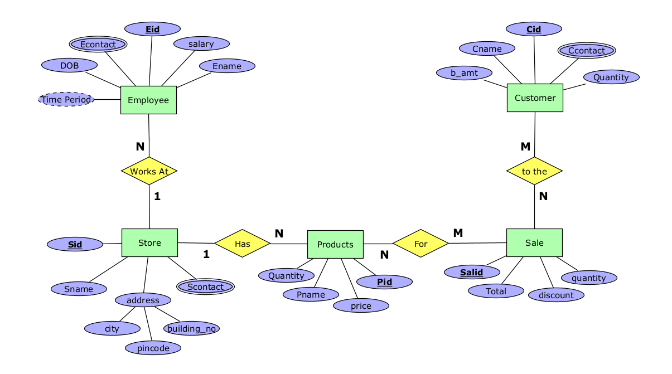

3.Relational Schema:

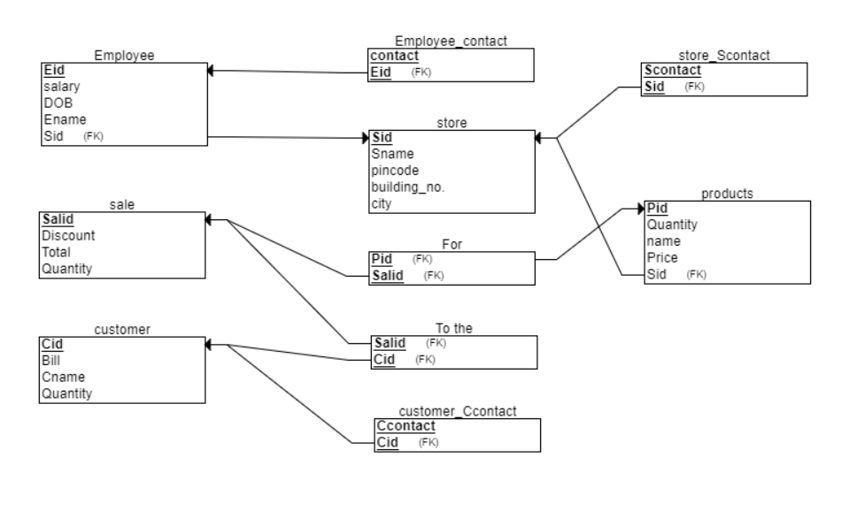

4.Normalization:

* Normalization is the process of organizing the data in the database. It is used to minimize the redundancy from a relation or set of relations. It is also used to eliminate undesirable characteristics like Insertion, Update, and Deletion Anomalies.
* Normalization divides the larger table into smaller and links them using relationships.

There are 5 Normal forms:

1. First Normal Form (1NF)

2. Second Normal Form (2NF)

3. Third Normal Form (3NF) or Boyes Cord Normal Form (BCNF)

4. Fourth Normal Form (4NF)

5. Fifth Normal Form (5F) or Project Join Normal Form (PJNF)

**1st Normal Form:**

A relation is in first normal form if the relation contains non atomic attributes.

* In the undertaken project every relation has non-atomic attributes only.so the project is in 1NF.

**2nd Normal Form:**

It should be in 1NF and,

A relation is said to be in 2NF if it contains a primary key or super key.

Every relation must contain full functional dependency.

* The given schema has super key in every relation, so it is in 2NF

**3rd Normal Form:**

A relation must be 2NF and,

there shall be no transitive dependencies in the relation.

* In the undertaken schema transitive functional dependency exists in store relation between the attributes Sid, pincode and city.
* Sid->pin code->city, so city is removed from the main table and a new table is created containing pincode and city.

hence the given schema is now in 3NF form.

Relations After Normalization:

**Employee**

| Eid(pk) | Fname | Lname | salary | DOB | Sid(fk) |
| --- | --- | --- | --- | --- | --- |

| Sid | Econtact |
| --- | --- |

**Store**

| Sid(pk) | Sname | building_no | pincode |
| --- | --- | --- | --- |

| pincode(pk) | city |
| --- | --- |

| Sid | Scontact |
| --- | --- |

**Sale**

| Salid | total | quantity | discount |
| --- | --- | --- | --- |

**Customer**

| Cid | Fname | Lname | b_amt | quantity |
| --- | --- | --- | --- | --- |

| Cid | Ccontact |
| --- | --- |

**Product**

| Pid(pk) | price | quantity | name | Sid(fk) |
| --- | --- | --- | --- | --- |

**Sale_Customer**

| Sid(fk) | Cid(fk) |
| --- | --- |

**Products_sale**

| Pid(fk) | Sid(fk) |
| --- | --- |

4.SQL Commands:

**4.1 Creating Tables & Value Insertion**

use db;

** Creating Table **

create table Store(

Sid int,

Sname varchar(50) not null,

Building_no varchar(30) not null,

pincode int not null,

primary key(sid)

);

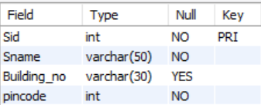

** Inserting Values **

insert into store values(12566, "Calvin klein", "12.3.4", 522007);

insert into store values(12562, "Carat lane", "10-5-1", 522006);

insert into store values(12563, "Danial Wellington", "01-8-4", 522005);

insert into store values(12564, "Mango", "07-3-4", 522001);

insert into store values(12565, "Damilano", "12-1-4", 522002);

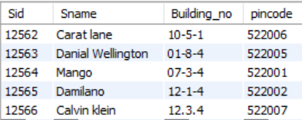

** Creating Table **

create table Storepc(

pincode int primary key,

city varchar(100) not null

);

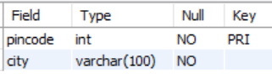

** Inserting Values **

insert into storepc values(522007, "Guntur");

insert into storepc values(522006, "Vijaywada");

insert into storepc values(522005, "Pondicherry");

insert into storepc values(522001, "Chennai");

insert into storepc values(522002, "Bangalore");

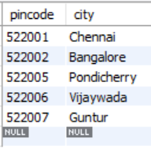

** Creating Table **

create table s_contact(

Sid int references Store(Sid),

Scontact varchar(30) not null,

primary key(Sid, Scontact)

);

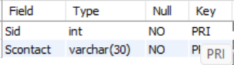

** Inserting Values **

insert into s_contact values(12566, "9550166632");

insert into s_contact values(12562, "9550699544");

insert into s_contact values(12563, "8688573293");

insert into s_contact values(12564, "9348148312");

insert into s_contact values(12565, "9944038626");

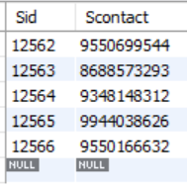

** Creating Table **

create table Employe(

Eid int,

Fname varchar(100) not null,

Lname varchar(100) not null,

salary int not null,

DOB date not null,

primary key(Eid),

Sid int references Store(Sid)

);

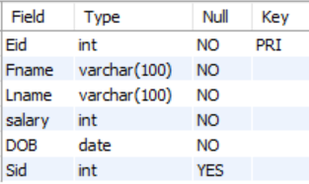

** Inserting Values **

insert into employe values(1,"Ankitha", "Gangavarapu", 10000, '03-10-10', 12566);

insert into employe values(2,"Achyuth", "Tadepalli", 10000, '03-10-14', 12566);

insert into employe values(3,"Phanindra", "Tupakula", 120000, '02-07-31', 12562);

insert into employe values(4,"Sanjeev", "Chitturi", 12000, '03-04-10', 12562);

insert into employe values(5,"Samhitha", "Gollamudi", 8000, '03-08-22', 12563);

insert into employe values(6,"Ram", "Potheneni", 10000, '03-06-12', 12563);

insert into employe values(7,"Manasa", "Mylavarapu", 10000, '03-11-14', 12564);

insert into employe values(8,"Dheeraj", "kommulapati", 10000, '03-04-20', 12564);

insert into employe values(9,"Harshith", "kolla", 15000, '02-11-09', 12565);

insert into employe values(10,"Sahithya", "Pptti", 12000, '03-03-01', 12565);

insert into employe values(11,"Abhigna", "Badam", 14000, '03-07-11', 125665);

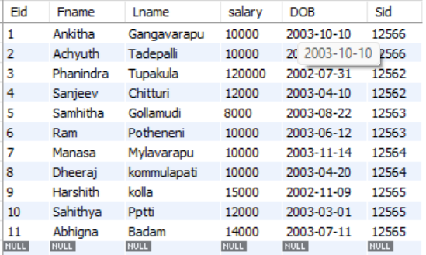

** Creating Table **

create table E_contact(

Eid int not null references Employe(Eid),

Econtact varchar(30) not null,

primary key(Eid, Econtact)

);

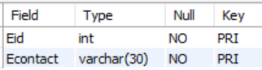

** Inserting Values **

insert into e_contact values(1, "9848528364");

insert into e_contact values(2, "9348148364");

insert into e_contact values(3, "9618958074");

insert into e_contact values(4, "9441177330");

insert into e_contact values(5, "8688573293");

insert into e_contact values(6, "8688559800");

insert into e_contact values(7, "9192546789");

insert into e_contact values(8, "9032699544");

insert into e_contact values(9, "7468388990");

insert into e_contact values(10, "7788507788");

insert into e_contact values(11, "8688559801");

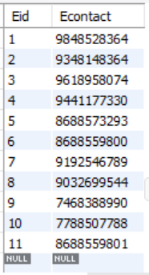

** Creating Table **

create table Product(

Pid int not null,

Price int not null,

Qunatity int not null,

Name varchar(100) not null,

Sid int references Store(Sid)

);

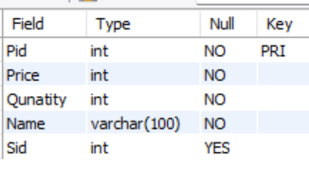

** Inserting Values **

insert into product values(110,5000,20,"Tote bags",12566);

insert into product values(1111,5000,4,"Tote bags",12566);

insert into product values(111,2000,10,"Euphoria",12566);

insert into product values(112,30000,10,"Pendents",12562);

insert into product values(1112,30000,3,"Pendents",12562);

insert into product values(113,20000,10,"Rings",12562);

insert into product values(114,15000,12,"Watches",12563);

insert into product values(115,3000,5,"Classic Bracelet",12563);

insert into product values(116,10000,4,"Wallets",12564);

insert into product values(117,12000,7,"Sunglasses",12564);

insert into product values(118,50000,4,"Clutches",12565);

insert into product values(1113,50000,1,"Clutches",12565);

insert into product values(119,40000,6,"Belt",12565);

insert into product values(1110,100000,12,"Breifcases",12565);

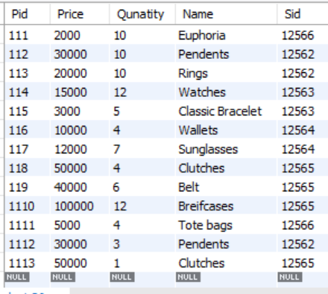

** Creating Table **

create table sale(

Salid int not null,

total int not null,

quantity int not null,

discount int not null,

primary key(Salid)

);

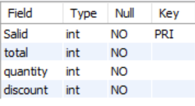

** Inserting Values **

insert into sale values(2235,4500,4,10 );

insert into sale values(2236,27000,3,10);

insert into sale values(2237,42500,1,15);

insert into sale values(2238,5000,20,0);

insert into sale values(2239,2000,10,0);

insert into sale values(2240,30000,10,0);

insert into sale values(2241,20000,10,0);

insert into sale values(2242,15000,12,0);

insert into sale values(2243,3000,5,0);

insert into sale values(2244,10000,4,0);

insert into sale values(2245,12000,7,0);

insert into sale values(2246,50000,4,0);

insert into sale values(2247,40000,6,0);

insert into sale values(2248,100000,12,0);

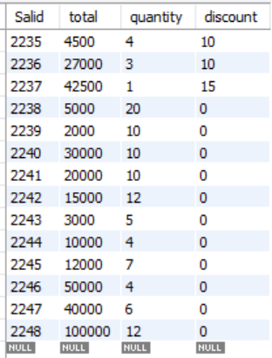

** Creating Table **

create table Customer(

Cid int,

Fname varchar(50) not null,

Lname varchar(50) not null,

b_amt int not null,

quantity int not null,

primary key(Cid)

);

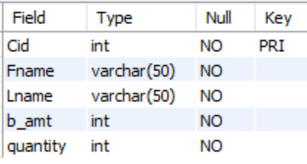

** Inserting Values **

insert into customer values (3330,"Chaitanya","Gangavarapu",9500,2 );

insert into customer values (3331,"Madhavi","Gangavarapu",47000,2);

insert into customer values (3332,"Elamathi","Muralidharan",15000,1);

insert into customer values (3333,"Navaneetha","Yandrapragada",20000,1);

insert into customer values (3334,"Pradeep","Yarlagadda",80000,2);

insert into customer values (3335,"Sampath","Goshika",190000,3);

insert into customer values (3336,"Harshini","Doppalapudi",50000,1);

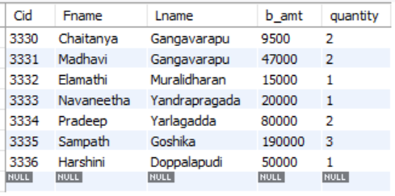

** Creating Table **

create table C_contact(

Cid int references Customer(Cid),

Ccontact varchar(30) not null,

primary key(Cid, Ccontact)

);

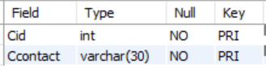

** Inserting Values **

insert into C_contact values (3330,"9550699544");

insert into C_contact values (3331,"9550199544");

insert into C_contact values (3332,"9550666632");

insert into C_contact values (3333,"9391230074");

insert into C_contact values (3334,"9291230074");

insert into C_contact values (3335,"9618561213");

insert into C_contact values (3336,"9490118079");

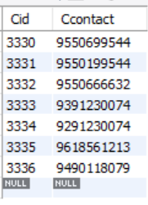

** Creating Table **

create table Products_Sale(

Pid int references Product(Pid),

Salid int references Sale(Salid),

primary key(PID, salid)

);

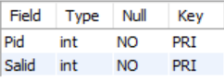

** Inserting Values **

insert into products_sale values(1111,2235);

insert into products_sale values(1112,2236);

insert into products_sale values(1113,2237);

insert into products_sale values(110,2238);

insert into products_sale values(111,2239);

insert into products_sale values(112,2240);

insert into products_sale values(113,2241);

insert into products_sale values(114,2242);

insert into products_sale values(115,2243);

insert into products_sale values(116,2244);

insert into products_sale values(117,2245);

insert into products_sale values(118,2246);

insert into products_sale values(119,2247);

insert into products_sale values(1110,2248);

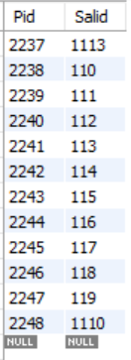

** Creating Table **

create table Sale_Customer(

Salid int references Sale(salid),

Cid int references customer(cid),

primary key(cid, salid)

);

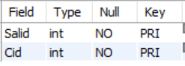

***Inserting Values***

insert into sale_customer values(2238,3330);

insert into sale_customer values(2235,3330);

insert into sale_customer values(2236,3331);

insert into sale_customer values(2240,3331);

insert into sale_customer values(2241,3333);

insert into sale_customer values(2247,3334);

insert into sale_customer values(2246,3335);

insert into sale_customer values(2247,3335);

insert into sale_customer values(2248,3335)

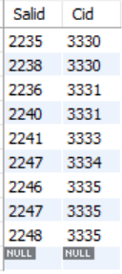

SQL Queries:

1.Name the customer who made the highest bill amount?  
Query: select fname, lname,b_amt from customer where b_amt =(select max(b_amt) from customer);

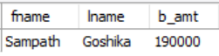

2.Name the employees who work at the store damilano?

Query: select fname, lname from employe e

join store s on e.sid = s.sid where sname = "damilano";

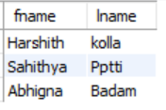

3. Name the customers who brought belts at the store damilano?

Query: select c.Fname, p.name, st.sname p.price from customer c

join sale_customer sc on c.cid = sc.cid

join sale s on sc.salid = s.salid

join products_sale ps on s.salid = ps.salid

join product p on ps.pid = p.pid

join store st on p.sid = st.sid

where st.sname = "damilano" and p.name="belt";

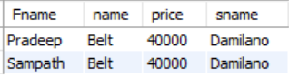

4.Name the products on discount?

Query:select product.name, sale.discount, product.price, sale.total as after_discount from product

join products_sale on product.pid = products_sale.pid

join sale on products_sale.salid = sale.salid where discount>0;

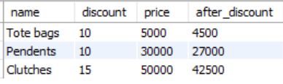

5. What is the contact number of the store carat lane?

Query: select store.sname as name, s_contact.scontact as contact from store

join s_contact on s_contact.sid = store.sid where store.sid = 12562;

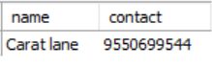

# References

1. https://stackoverflow.com/questions/63968573/how-to-select-customer-names-with-maximum-invoice-value